NGO Gallery – Photo Titles (Batch 2)
Photos 21–40 · short English titles for the gallery page
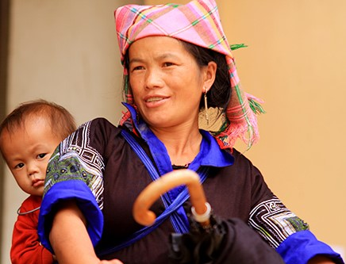  21 Held Close  1412061364-tre-vung-cao--16-.jpg | 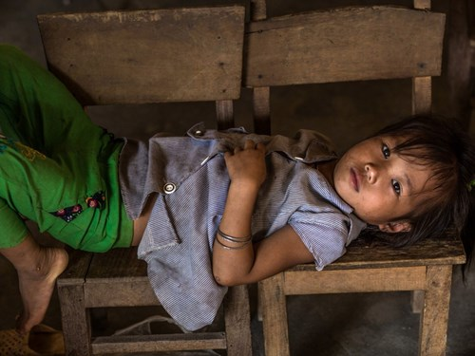  22 Resting, Still Hoping  1444799099-vietnam15_fqfw.jpg
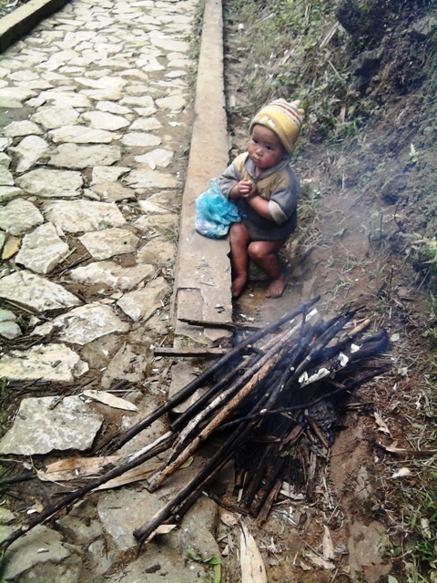  23 A Cold Morning Wait  20160124194113-a1.jpg | 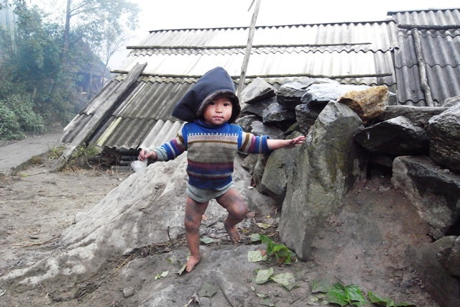  24 Barefoot in the Cold  20160124194113-a3.jpg
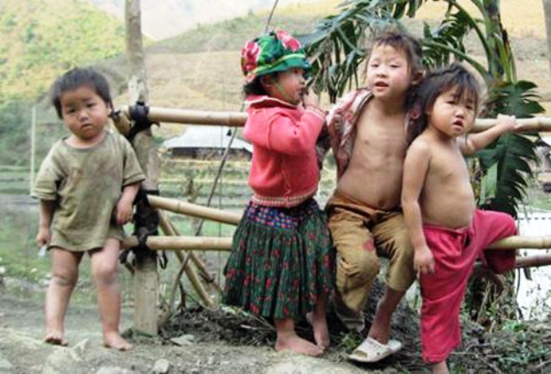  25 Standing Together  20160124194113-a4.jpg | 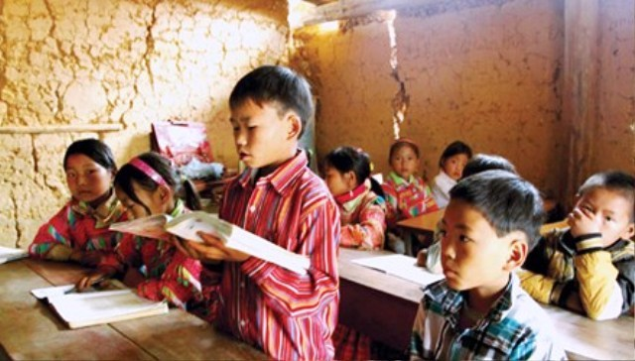  26 Learning Against the Odds  20160124194113-a7.jpg
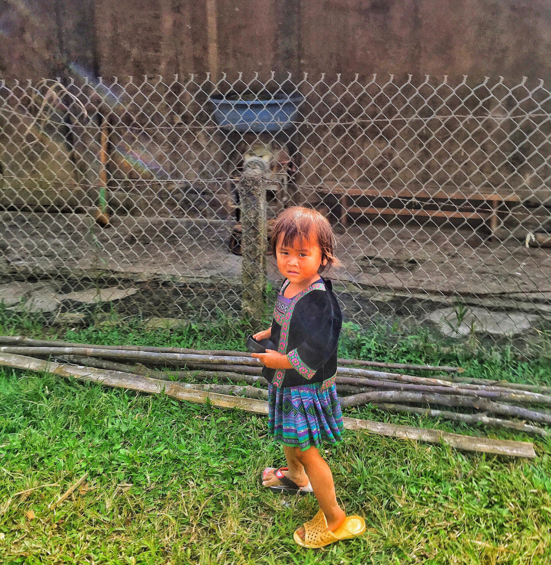  27 Room to Grow  ae48fd307ee87b243b03f108c3fa08c8.jpg | 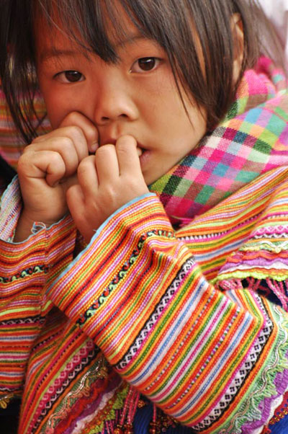  28 Whispered Wishes  be-1.jpg
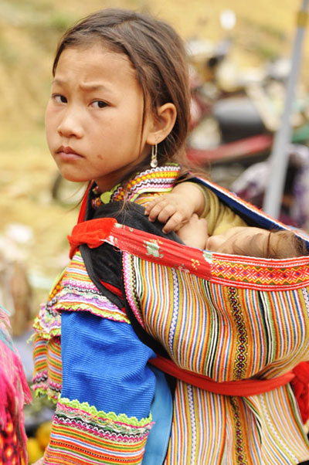  29 Growing Up Too Fast  be-2.jpg | 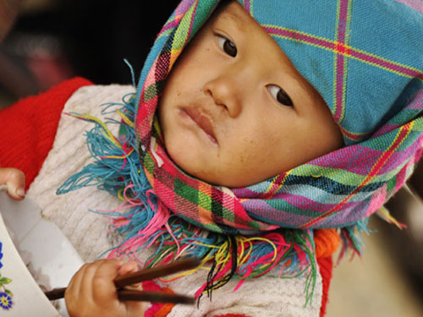  30 Every Bowl Counts  be-4.jpg
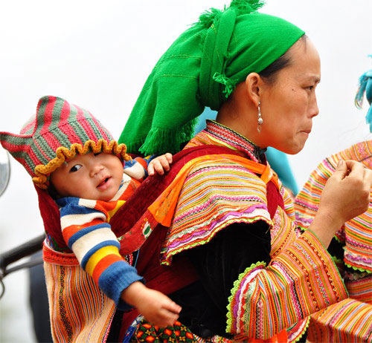  31 Carried with Love  be-7.jpg | 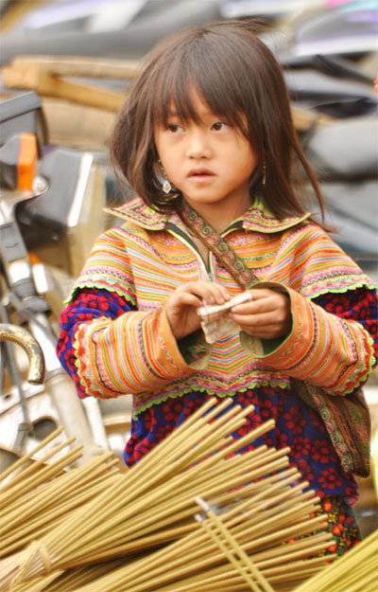  32 Small Hands at Work  be-8.jpg
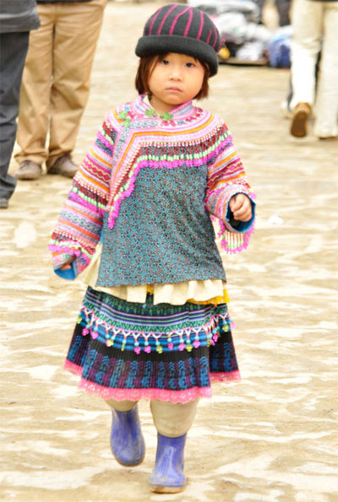  33 Walking Her Own Way  be-9.jpg | 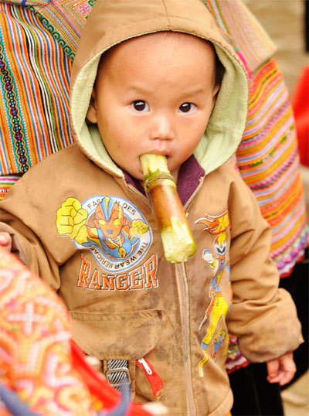  34 A Sweet Little Moment  be-10.jpg
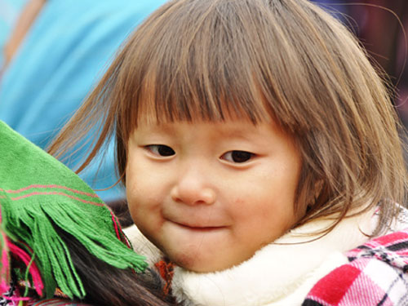  35 A Quiet Smile  be-11.jpg | 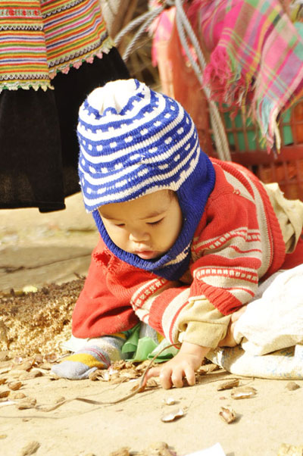  36 Little Explorer  be-12.jpg
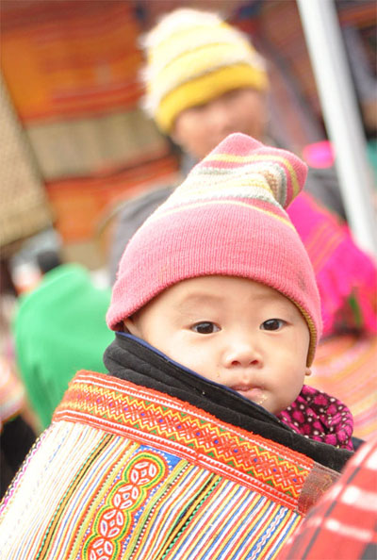  37 Wide-Eyed Wonder  be-13.jpg | 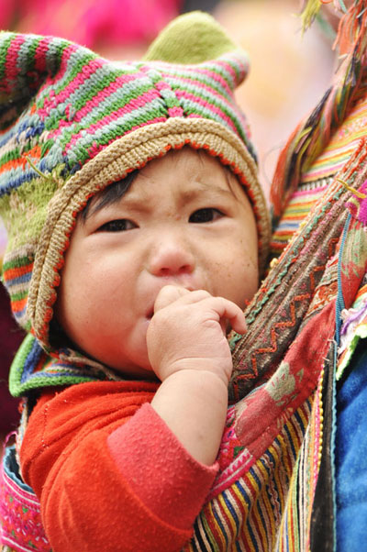  38 Every Tear Matters  be-14.jpg
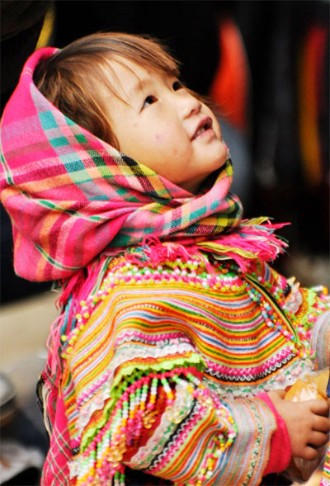  39 Brighter Days Ahead  be-15.jpg | 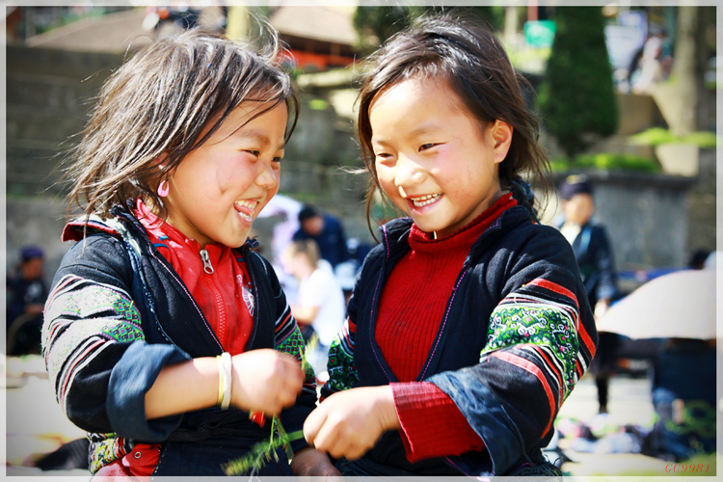  40 Laughing Together  be-vung-cao2-giaoduc_net_vn.jpg

